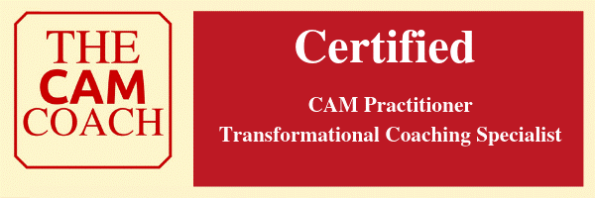

Credentials
Accredited Counsellors, Coaches, Psychotherapist and Hypnotherapists (ACCPH Senior member) DBS certified P0004B58L6E
Member of the National Council of Psychotherapists (NCP)
Institute for Leadership and Development (ILM)
Qualified Institute for Leadership and Development Coach
Complimentary Alternative Medicine practitioner (CAM Coach)
Qualified Transformational Life Coach
Hypnotherapy
Qualified Clinical Hypnotherapist
NLP
Qualified Neurolinguistic Programming practitioner and Emotional Freedom Technique practitioner (EFT)
Qualified Trainer/Teacher
Qualified Status teacher and trainer and member of the Society of Education and Teaching (SET)
Meditation
Certified Meditation practitioner

